Rulebook:

Knight’s Duty

**Contents**

A Knight’s Duty 2

Objective 2

Components 2

Setup 3

The Turns 3

Actions And Resolve Phase 3

Movement 3

Swapping equipment 4

Defending 4

Parrying 4

Attacking 4

Inspiration 4

Resolving combat 5

The weapon: 5

If the target is defending: 5

Inspiration: 5

Hit or Miss 5

On a Miss 5

On a Hit 5

The High Ground 6

Winning 6

# A Knight’s Duty

Knight's duty is a turn-based free-for-all game for 2 to 6 players.

# Objective

The Goal of the game is to be the last man standing.

You achieve that by attacking and defeating other players, while avoiding getting attacked and defeated yourself.

# Components

* Game Manual,
* 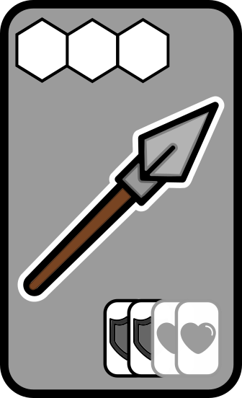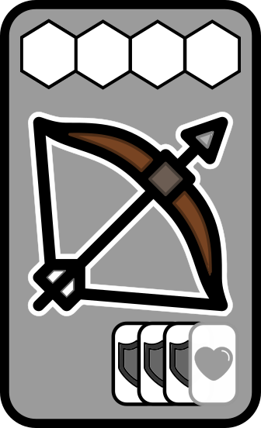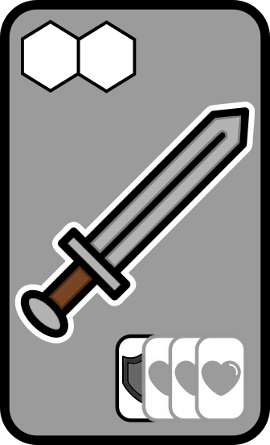Game Board,
* 6 clans, composed each of:
  + Equipment miniatu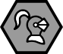res (1 Sword, 1 Spear, 1 Bow)
  + 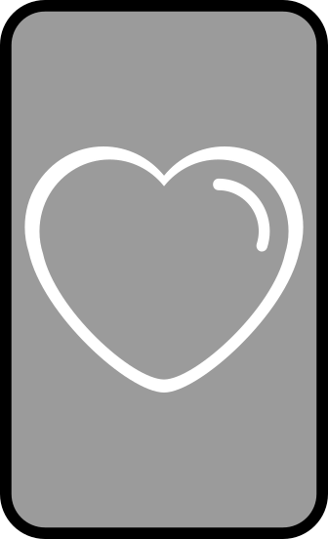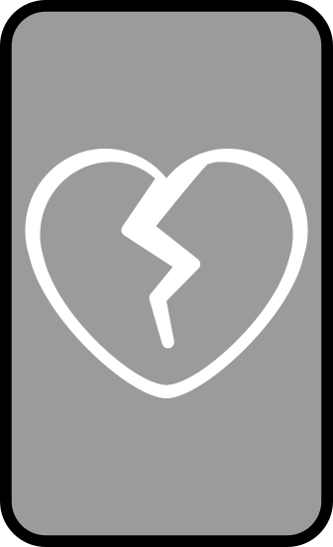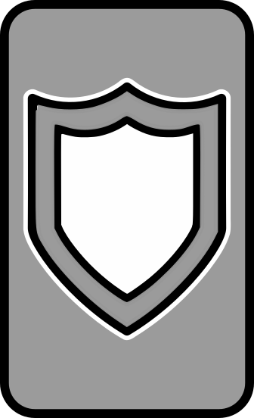Knight miniature
  + Battle cards (4 Full Heart, 4 Broken Heart, 4 Shields)
  + Action tokens:
    - 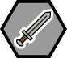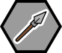2 Sword tokens,
    - 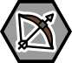2 Spear tokens,
    - 2 Bow tokens,
    - 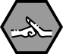2 Shield tokens,
    - 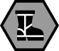2 Parry tokens,
    - 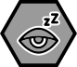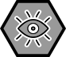3 Movement tokens,
    - 1 Inspiration token.

# Setup

Each player chooses a Clan. Each corner belongs to the clan that matches its colors.

Players place their **Knight** and **Inspiration token** on their corner, as well as a stack of Full Heart and Shield cards next to their corner, visible to other players.

# The Turns

Every turn, all the players pick actions for the turn by putting their action tokens face down on their tracker.

The number of actions you can do is determined by whether you have a Full or a Broken heart.

Every player starts with a Full Heart, being able to play 3 actions per turn. After getting hit once, they play with a Broken Heart, being able to play only 2 actions per turn.

After every player has put their actions face down on the tracker, reveal the first and resolve. After resolution, repeat for the second action, revealing and resolving. Finally, reveal and resolve the third action, if any.

Players with Broken hearts are not able to play the last action, but can be targeted and defend themselves accordingly.

# Actions And Resolve Phase

Actions are resolved simultaneously for every player, following a priority order.

The possible actions are the following, in the order they are resolved.

* Movement
* Change equipment
* Defending
* Parrying
* Attacking

During combat, you can also:

* Use Inspiration

### Movement

Movement allows that player's Knight to move on the battle field.

To make a movement action, simply place a movement( ) token on the tracker.

Players that used this action move their Knight 1 space in any direction. All players move at the same time.

You can't move into the same space as another player Knight, nor outside of the play area. Players can choose to stay in place if they wish.

If players want to move to the same space at the same time, they can make a gentleman's agreement over who gets to move to that space, otherwise both do not move.

### 

### Swapping equipment

Every player has 3 possible weapons, the sword ( ), the spear ( ), and the bow ( ).

To take a swap equipment action, place a weapon token that is different than the one you currently have equipped (you start without one).

That player then puts the new weapon miniature next to their corner, removing the old one. This is now the weapon they are equipped with.

Every weapon has a different range and chance to hit, described in details on the Attacking section.



### Defending

Defending increases your chances of not getting hit on a combat.

To make a defend action, place the shield ( ) token on the tracker.

If you are a target of any attack action within this phase of the tracker, you count as *Defending* while resolving combat.

### 

### **Parrying**

Parrying allows you to counter you opponent while in combat.

To make a parry action, place the parry ( ) token on the tracker.

If you are a target of any attack action within this phase of the tracker, you count as *Parrying* while resolving combat.

### Attacking

Attacking is how you try to hit your opponents hearts.

To make an attack action, place a weapon token equal to the one you are currently equipped with.(the one next to your corner)

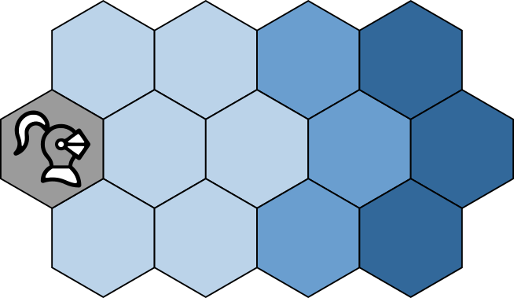Then, players that are attacking can declare their target within attack range. Each weapon has it's own range, being:

*  Sword: **1 to 2** spaces
*  Spear: **1 to 3** spaces
*  Bow: **1 to 4** spaces

If there's no opponent within range, your attack is forfeit. Player's can choose to target no one.

Attacks can be resolved in any order. If more than one player is targeting the same opponent, they can make a gentleman's agreement over who gets to attack first, while the other players can wait for that attack to resolve to choose a new target or the same one.

A player that takes damage or is defeated in combat can still be both attacker and target until this phase is resolved.

To resolve combat, see the ***Resolving combat*** section.

### 

### Using Inspiration

Inspiration allows you to tip the odds in your favour.

It can only be used if the *Inspiration token* is face-up ( )

Inspiration can be used while resolving a combat, both by the attacker and the target, as described in the ***Resolving combat*** section.

After it's use, turn the *Inspiration token* face-down ( ).

Inspiration can be recovered by defeating an opponent, or standing on **High Ground** (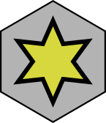 ).

If any knight lands on **High Ground** or starts it's turn on it, immediately turn the *Inspiration token* face up if it isn't already.

## **Resolving combat**

If an attacking player targets an opponent within range, a combat occurs.

To resolve it, the **targeted player** shuffles shields and hearts into a pile. The amount of hearts and shields depends on the attacker's weapon, if the target is defending, and the use of inspirations.

### The weapon:

* Bow: add 1 Heart and 3 Shields to the pile;
* Spear: add 2 Hearts and 2 Shields to the pile;
* Sword: add 3 Hearts and 1 Shield to the pile;

### If the target is defending:

Remove 1 Heart and add 1 Shield on the pile;

### Inspiration:

At this point, both player can choose to use inspiration if they have that token face up.

* Attacker uses inspiration: add 1 Heart to the pile;
* Defender uses inspiration: add 1 Shield to the pile;

### Hit or Miss

After adding the cards, targeted player shuffles the pile and presents it to the attacking player face down.

The attacking player then picks a card from the pile. If it is a Shield, the attack misses. If it is a Heart, the strike is true, and hits.

## **On a Miss**

On a miss, the attack does no harm to the targeted player.

If the targeted player was *Parrying*, the attacking player fumbles and unequips their weapon, going back to having none. This combat is now resolved.

## **On a Hit**

On a hit, the strike goes through the targeted opponent defenses and hits their heart.

If the target was playing with a **Full Heart**, they are now playing with a **Broken Heart**. Remove the Full Heart cards from the table and put in their place the Broken Heart cards, within view of other players. From now on, that player can make only 2 actions per turn.

If the target was playing with a Broken Heart, that player is defeated in battle, After all attacks in this combat phase are resolved, that player removes their knight from the board and is out of the game.

# The High Ground

The center of the board holds the High Ground space, marked with a .

If any knight lands on that space or starts it's turn on it, it regains inspiration if spent.

# Winning

The last Knight standing is declared victorious. If two or more players fall in battle in the same round and no one is left standing, the match is a draw.